

Empathy Map Canvas

Gain insight and understanding on solving customer problems.



1

Build empathy and keep your focus on the user by putting yourself in their shoes.



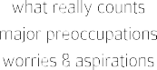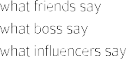

nice tech

save energy

save Easy

time touse

Docter more

help us helpful

easy to use

Iot Get low

occupy benefit cost

**Smart technology**

**More Required**

**sensible to continuous**

**all the suplly of**

**Required high voltage**

**No need to be scared**

**smoke current**

**Automatic Automatic execution extingusion of alarm of fire**

**Automatic process**

**No need for manual work**

**Good safety**